|  |  |  |
| --- | --- | --- |
| **Guide Name** | | **Panel Head** |
|  | Dr. V. RAJARAM |  |
|  |  |  |
|  | **Faculty Advisor** | **Project Domain** |
|  | Dr. V. RAJARAM |  |
| M |  |  |
|  | **Student(s) Details: Name** | **Passport size photo(s)** |
|  | 1. PRIYANSHU SINGH 2. ADITYA SINGH |  |
|  |  |  |

**Registration Number(s)**

1. RA2211030010036

2. RA2211030010034

**Email ID(s)&Mobile Number(s)**

|  |  |
| --- | --- |
| 1: ps9201@srmist.edu.in | 2: as2769@srmist.edu.in |

**Abstract Architecture Diagram**

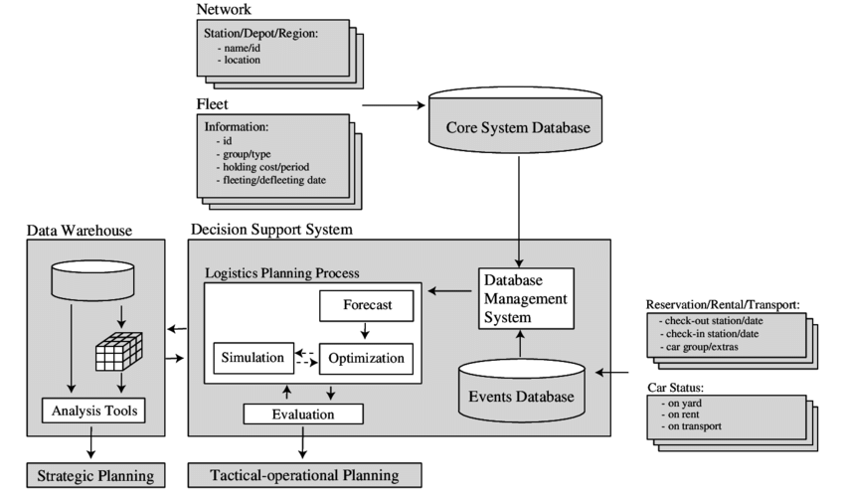

This project outlines the development of a comprehensive vehicle rental system designed to connect vehicle owners with customers seeking flexible transportation options. The platform will enable vehicle owners to register and manage their vehicles, including secure uploading of legal documentation for verification. Customers will be able to browse a diverse range of vehicles – including bikes, cars, and electric vehicles – based on location, availability, and pricing. The system will feature a user-friendly interface with advanced search and filtering capabilities, allowing customers to easily find the perfect vehicle for their needs. A key component of the system is the secure integration of a payment gateway, facilitating seamless and secure online transactions for bookings and potential security deposits. Furthermore, the system will offer flexible rental duration options, catering to both short-term and long-term rental needs. The architecture emphasizes security, scalability, and reliability, ensuring a robust and trustworthy platform for both vehicle owners and customers. This system aims to streamline the vehicle rental process, providing a convenient and efficient solution for transportation needs across the country.

**Significance of the Project Conclusion**

1. **Enhanced Convenience and Accessibility:**  
   The IndiaRide platform provides a user-friendly interface that allows customers to easily browse, book, and manage vehicle rentals online. This accessibility caters to travelers and locals alike, ensuring they can find transportation options without the hassle of traditional rental processes.
2. **Cost-Effectiveness:**  
   By offering a variety of vehicles for rent—including bikes, cars, and electric vehicles—IndiaRide presents an economical alternative to vehicle ownership. Users can select rental options that best fit their budgets and travel needs, reducing the financial burden associated with maintaining a personal vehicle.
3. **Digital Transformation in Transportation:**  
   The project leverages modern technology to automate the vehicle rental process, aligning with the ongoing digital transformation in the transportation industry. This includes features such as online reservations, secure payment processing, and real-time vehicle availability tracking.
4. **Sustainability Initiatives:**  
   By incorporating electric vehicles into its offerings, IndiaRide promotes environmentally friendly transportation options. This aligns with global sustainability goals by encouraging users to choose greener alternatives over traditional fossil fuel-powered vehicles.
5. **Adaptation to Changing Consumer Preferences:**  
   With a growing trend towards shared mobility solutions among younger generations, IndiaRide addresses the shift in consumer behavior by offering flexible rental options that cater to modern lifestyles. This adaptability positions the platform favorably within the evolving landscape of urban transportation.
6. **Support for Local Economies:**  
   By enabling local vehicle owners to list their vehicles on the platform, IndiaRide supports community engagement and economic growth. Vehicle owners can generate income while providing essential transportation services to users in their area.
7. **Safety and Security Measures:**  
   The project emphasizes secure transactions and verification processes for both vehicle owners and renters. This focus on safety helps build trust within the platform, encouraging more users to participate in the rental ecosystem.

In conclusion, the **IndiaRide** project offers a transformative solution for vehicle rentals in India. By leveraging technology to streamline processes, enhance convenience, and promote sustainability, IndiaRide addresses key challenges in the transportation sector. The platform not only connects vehicle owners with potential renters but also fosters economic growth by providing income opportunities and facilitating access to flexible mobility options. With its emphasis on secure transactions, data-driven insights, and adaptation to evolving consumer preferences, IndiaRide is poised to become a leading force in revolutionizing how people access transportation solutions throughout India, making travel more accessible, affordable, and environmentally responsible. The success of IndiaRide will not only benefit its users but also contribute positively to the country's transportation ecosystem and economy.

**Conference/Journal Publication Details (Mandatory)**

[1]. F. Y. H. Ahmed, E. B. Hazlan and M. I. Abdulla, "Enhancement of Mobile-Based Application for Vehicle Rental," *2021 IEEE 11th IEEE Symposium on Computer Applications & Industrial Electronics (ISCAIE)*, Penang, Malaysia, 2021, pp. 163-168, doi: 10.1109/ISCAIE51753.2021.9431820.

[2]. S. Hu, H. Lin, K. Xie, X. Chen and H. Shi, "Modeling users' vehicles selection behavior in the urban carsharing program," *2018 21st International Conference on Intelligent Transportation Systems (ITSC)*, Maui, HI, USA, 2018, pp. 1546-1551, doi: 10.1109/ITSC.2018.8569386.

[3]. T. Vinod, N. Kumaresan, I. Gugan, S. Dhanasekaran, K. Ramprathap and P. Chinnasamy, "Online Automobile Rental and E-Marketplace with Augmented Reality (AR)," *2022 International Conference on Advancements in Smart, Secure and Intelligent Computing (ASSIC)*, Bhubaneswar, India, 2022, pp. 1-5, doi: 10.1109/ASSIC55218.2022.10088370.

[4]. K. Hara, M. Teramoto and M. Takayama, "The electric vehicle sharing demonstration: the ITS/EV project urban rent-a-car system in the Yokohama Minato Mirai 21 area," *Proceedings of the IEEE Intelligent Vehicles Symposium 2000 (Cat. No.00TH8511)*, Dearborn, MI, USA, 2000, pp. 116-121, doi: 10.1109/IVS.2000.898328.

[5]. S. Thapa, S. R. Sahoo, M. Patra and A. Gupta, "A Novel Cost-Aware Load Balancing Algorithm for Road Side Units in Internet of Vehicles," *2022 18th International Conference on Network and Service Management (CNSM)*, Thessaloniki, Greece, 2022, pp. 359-363, doi: 10.23919/CNSM55787.2022.9964580.

[6]. P. -Y. Chang and H. -Y. Lin, "The Comparison of the Cost Effection on Pick up and Delivery, and Traditional Distribution Center Vehicle Routing," *2017 International Conference on Industrial Engineering, Management Science and Application (ICIMSA)*, Seoul, Korea (South), 2017, pp. 1-5, doi: 10.1109/ICIMSA.2017.7985608.

[7]. K. Hara, "ITS for rent [intelligent transport systems]," in *IEEE Intelligent Systems and their Applications*, vol. 15, no. 5, pp. 84-85, Sept.-Oct. 2000, doi: 10.1109/5254.889111.

[8]. S. Patil, D. Adsul, S. Desale and K. Gandole, "Smart Vehicle Rental Application using Blockchain and IoT," *2022 International Conference on Smart Generation Computing, Communication and Networking (SMART GENCON)*, Bangalore, India, 2022, pp. 1-6, doi: 10.1109/SMARTGENCON56628.2022.10084014.

[9]. N. Jeba, N. Harishkumar, M. Yogeshwaran and M. A. Kumar, "Online Vehicle Rental System to Enhance Commutation," *2021 International Conference on Advancements in Electrical, Electronics, Communication, Computing and Automation (ICAECA)*, Coimbatore, India, 2021, pp. 1-5, doi: 10.1109/ICAECA52838.2021.9675672.